Test Case: tc002_SPX_Dev5_Crear_Requisicion_Spot_Con_FAD_Tipo_Cobro_CC
Step 1 - Enter username and password and click to button Enter : Credentials Entered
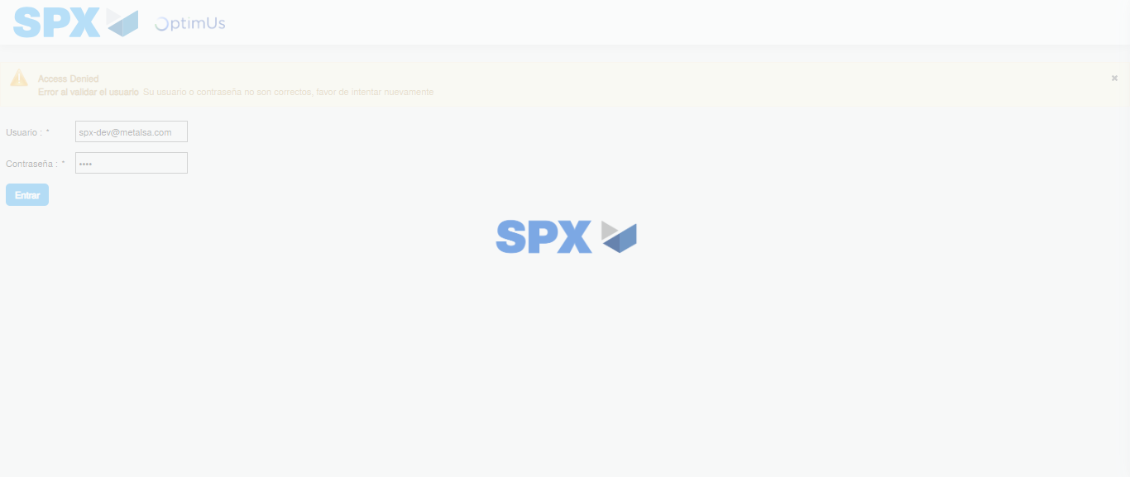Image file-name: QC_Testing-tc002_SPX_Dev5_Crear_Requisicion_Spot_Con_FAD_Tipo_Cobro_CC-1785975702329

Step 2 - Select to UEN and Access to Spot Buy Requisitions : UEN Correctly selected and Correct access
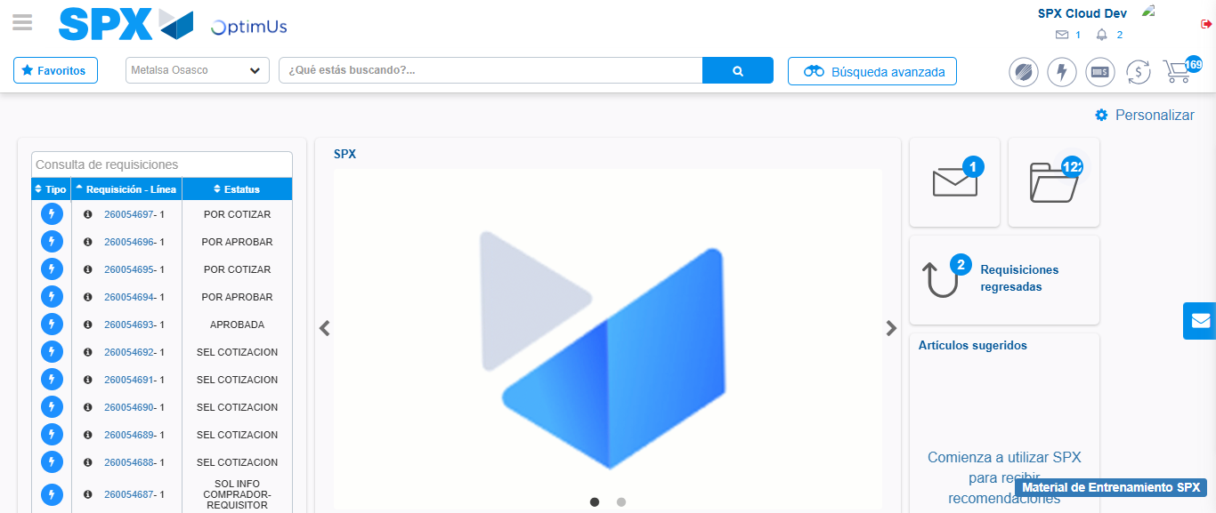Image file-name: QC_Testing-tc002_SPX_Dev5_Crear_Requisicion_Spot_Con_FAD_Tipo_Cobro_CC-1785975727651

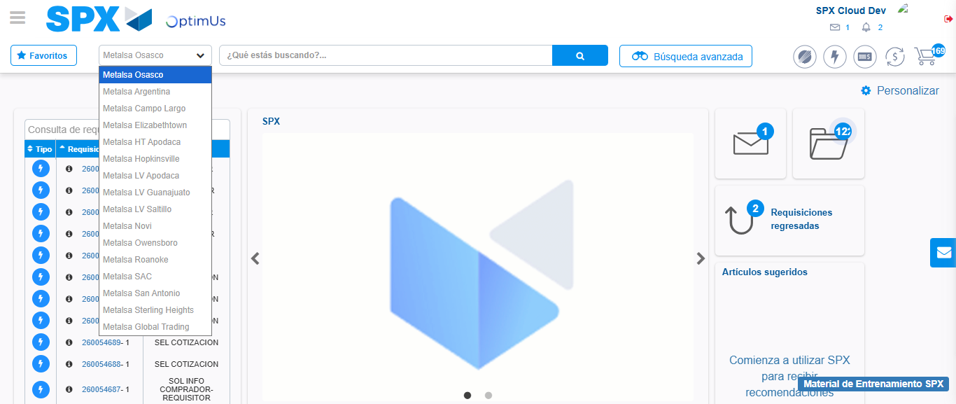Image file-name: QC_Testing-tc002_SPX_Dev5_Crear_Requisicion_Spot_Con_FAD_Tipo_Cobro_CC-1785975730527

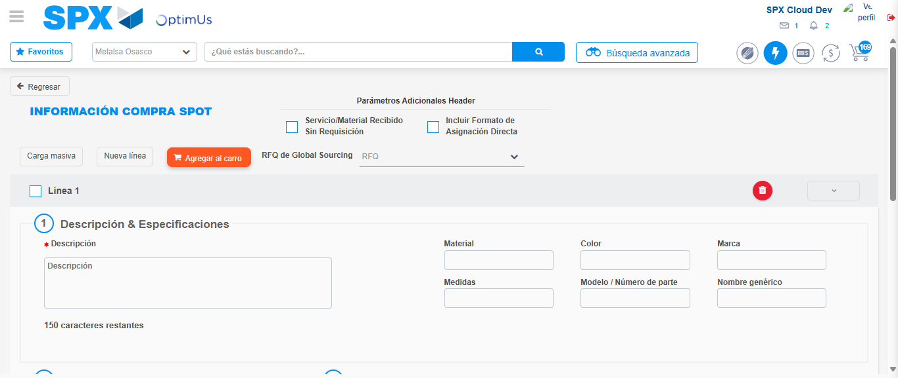Image file-name: QC_Testing-tc002_SPX_Dev5_Crear_Requisicion_Spot_Con_FAD_Tipo_Cobro_CC-1785975737283

Step 3 - Add FAD to Requisition: FAD Successfully Added
Image file-name: QC_Testing-tc002_SPX_Dev5_Crear_Requisicion_Spot_Con_FAD_Tipo_Cobro_CC-1785975737514

Image file-name: QC_Testing-tc002_SPX_Dev5_Crear_Requisicion_Spot_Con_FAD_Tipo_Cobro_CC-1785975737698

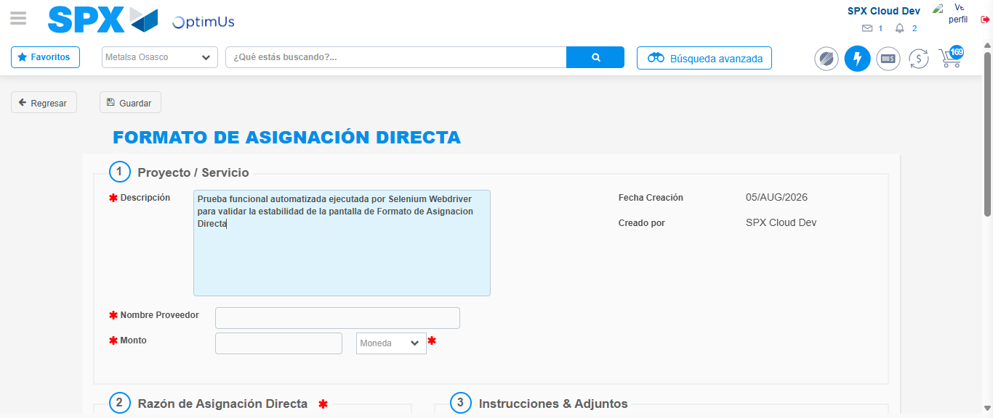Image file-name: QC_Testing-tc002_SPX_Dev5_Crear_Requisicion_Spot_Con_FAD_Tipo_Cobro_CC-1785975740697

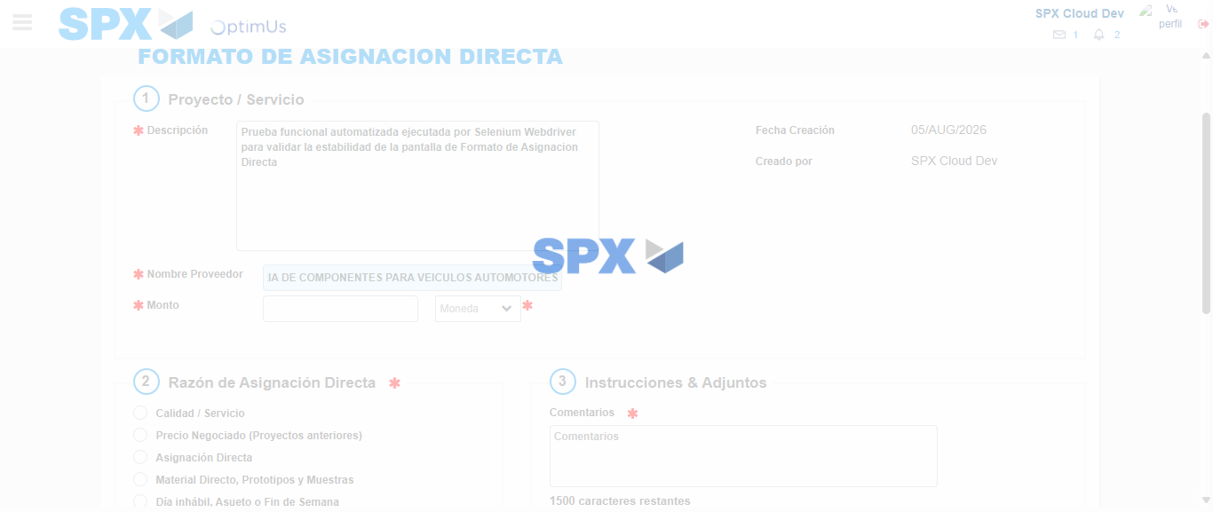Image file-name: QC_Testing-tc002_SPX_Dev5_Crear_Requisicion_Spot_Con_FAD_Tipo_Cobro_CC-1785975752467

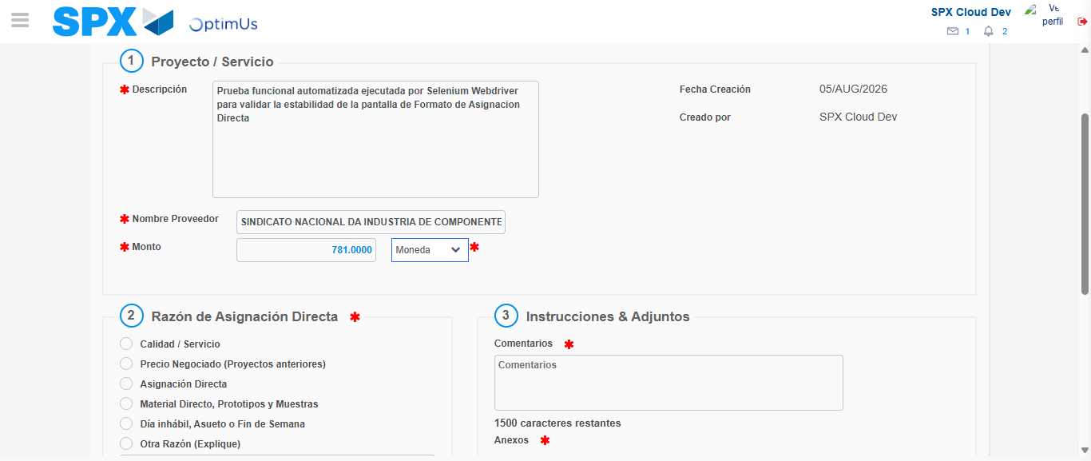Image file-name: QC_Testing-tc002_SPX_Dev5_Crear_Requisicion_Spot_Con_FAD_Tipo_Cobro_CC-1785975752956

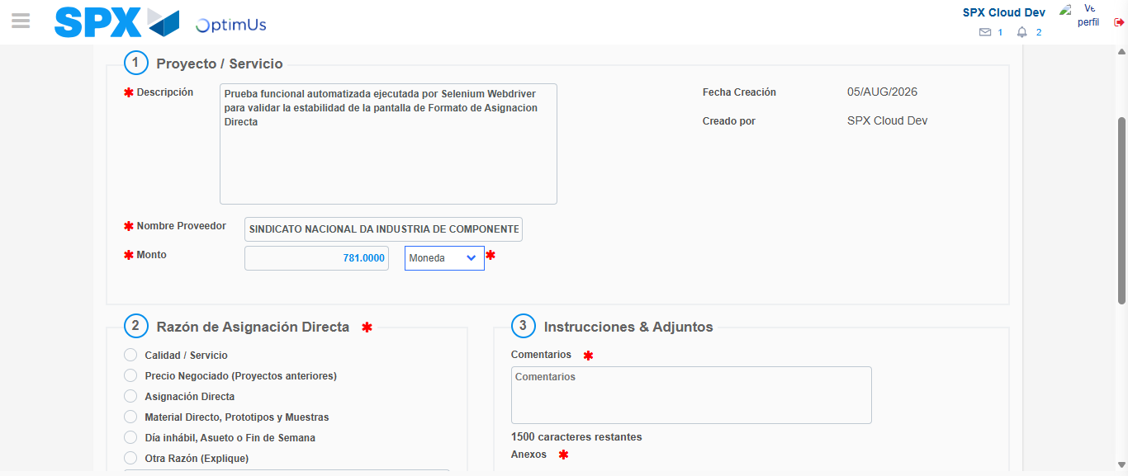Image file-name: QC_Testing-tc002_SPX_Dev5_Crear_Requisicion_Spot_Con_FAD_Tipo_Cobro_CC-1785975753190

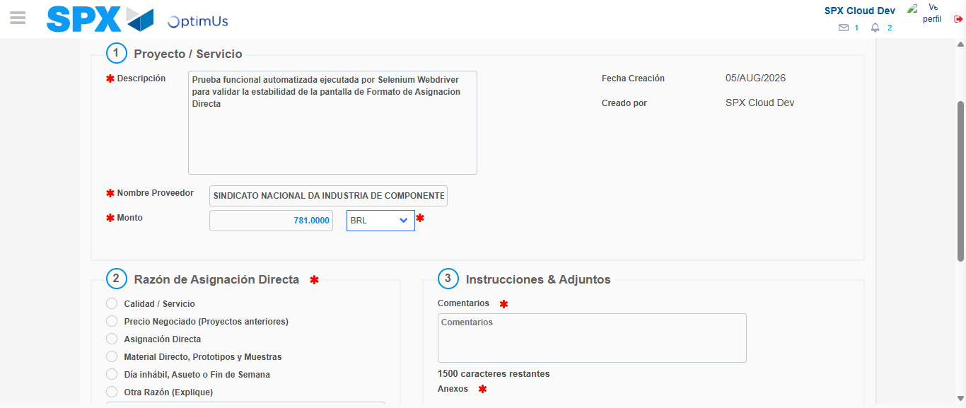Image file-name: QC_Testing-tc002_SPX_Dev5_Crear_Requisicion_Spot_Con_FAD_Tipo_Cobro_CC-1785975753684

Image file-name: QC_Testing-tc002_SPX_Dev5_Crear_Requisicion_Spot_Con_FAD_Tipo_Cobro_CC-1785975753891

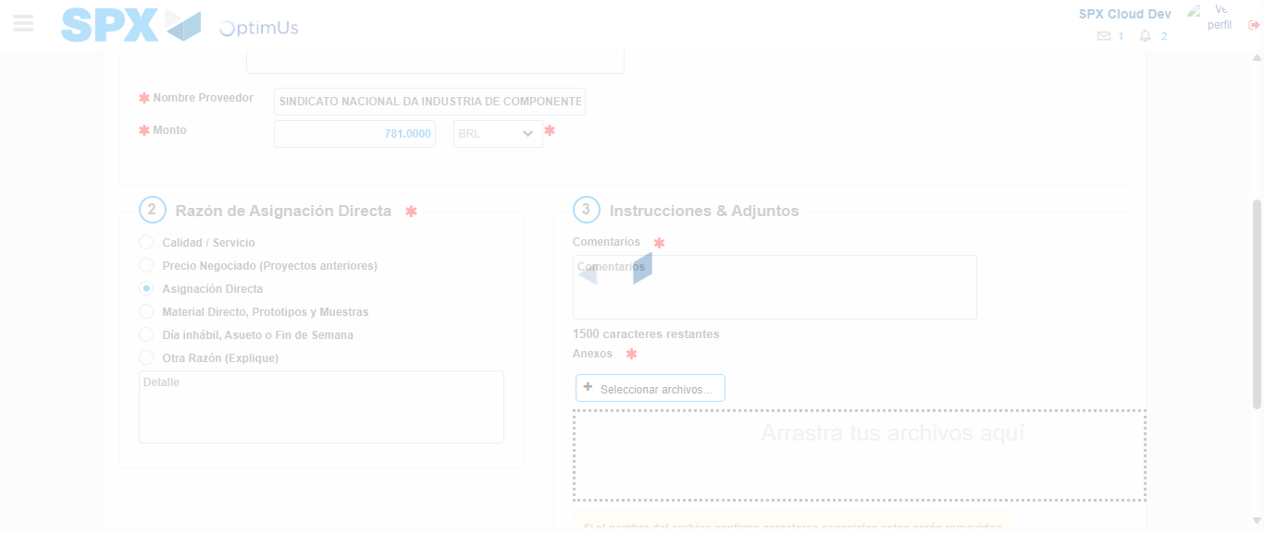Image file-name: QC_Testing-tc002_SPX_Dev5_Crear_Requisicion_Spot_Con_FAD_Tipo_Cobro_CC-1785975754907

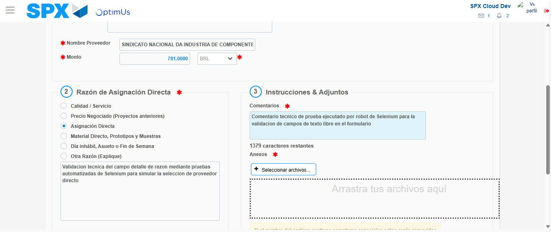Image file-name: QC_Testing-tc002_SPX_Dev5_Crear_Requisicion_Spot_Con_FAD_Tipo_Cobro_CC-1785975766218

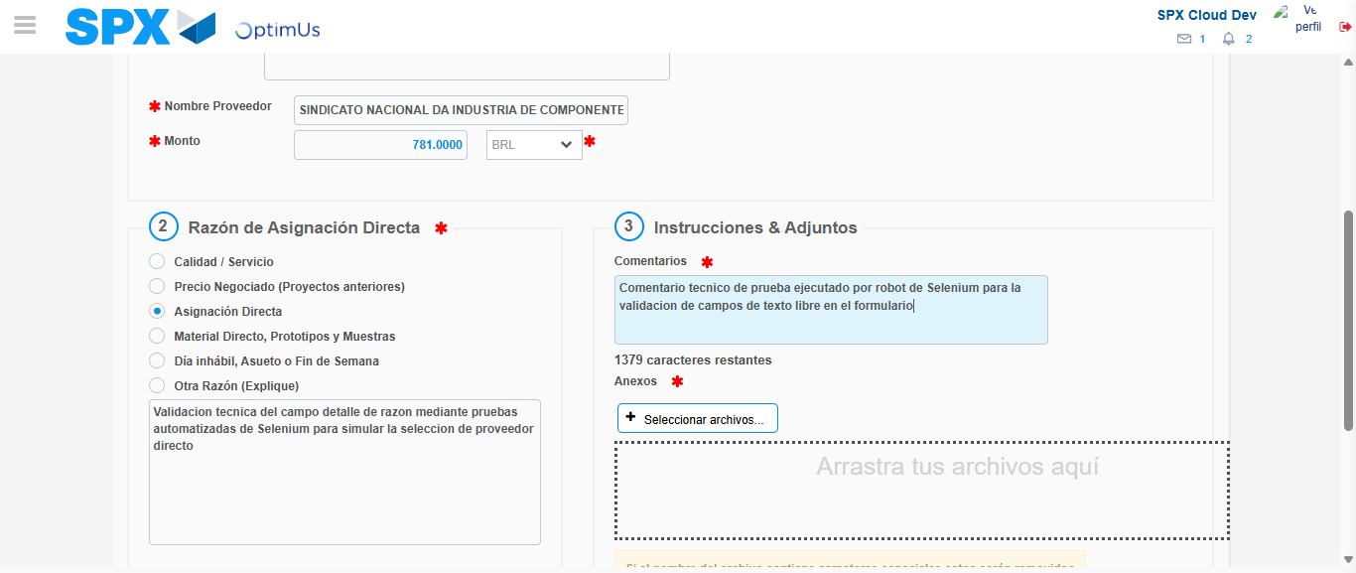Image file-name: QC_Testing-tc002_SPX_Dev5_Crear_Requisicion_Spot_Con_FAD_Tipo_Cobro_CC-1785975766799

Step 4 - Data Capture Spot Buy Requisition: Data captured correctly
Image file-name: QC_Testing-tc002_SPX_Dev5_Crear_Requisicion_Spot_Con_FAD_Tipo_Cobro_CC-1785975737514

Image file-name: QC_Testing-tc002_SPX_Dev5_Crear_Requisicion_Spot_Con_FAD_Tipo_Cobro_CC-1785975737698

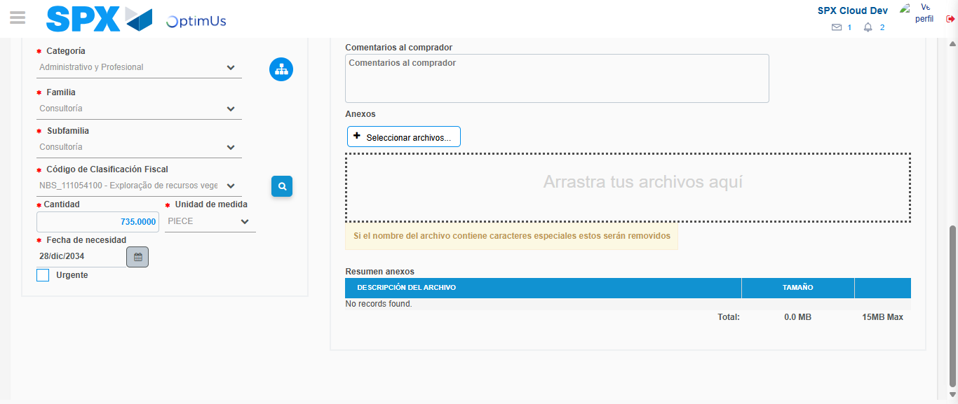Image file-name: QC_Testing-tc002_SPX_Dev5_Crear_Requisicion_Spot_Con_FAD_Tipo_Cobro_CC-1785975785701

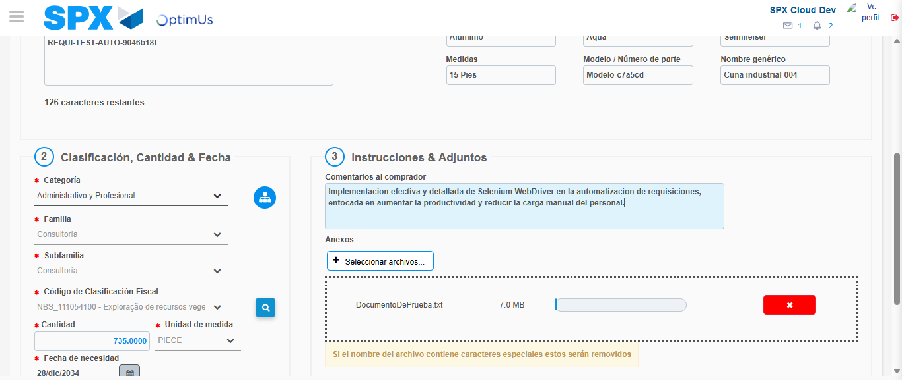Image file-name: QC_Testing-tc002_SPX_Dev5_Crear_Requisicion_Spot_Con_FAD_Tipo_Cobro_CC-1785975786432

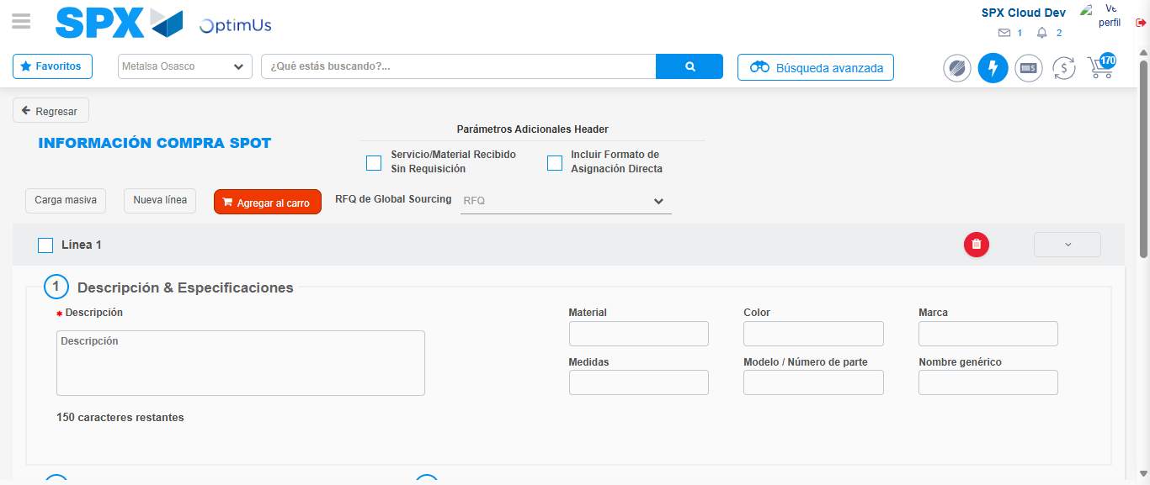Image file-name: QC_Testing-tc002_SPX_Dev5_Crear_Requisicion_Spot_Con_FAD_Tipo_Cobro_CC-1785975801979

Step 8 - Return to Main Page SPX : Return to Main Page SPX
Image file-name: QC_Testing-tc002_SPX_Dev5_Crear_Requisicion_Spot_Con_FAD_Tipo_Cobro_CC-1785975727651

Image file-name: QC_Testing-tc002_SPX_Dev5_Crear_Requisicion_Spot_Con_FAD_Tipo_Cobro_CC-1785975730527

Image file-name: QC_Testing-tc002_SPX_Dev5_Crear_Requisicion_Spot_Con_FAD_Tipo_Cobro_CC-1785975737283

Image file-name: QC_Testing-tc002_SPX_Dev5_Crear_Requisicion_Spot_Con_FAD_Tipo_Cobro_CC-1785975804226

Image file-name: QC_Testing-tc002_SPX_Dev5_Crear_Requisicion_Spot_Con_FAD_Tipo_Cobro_CC-1785975804408

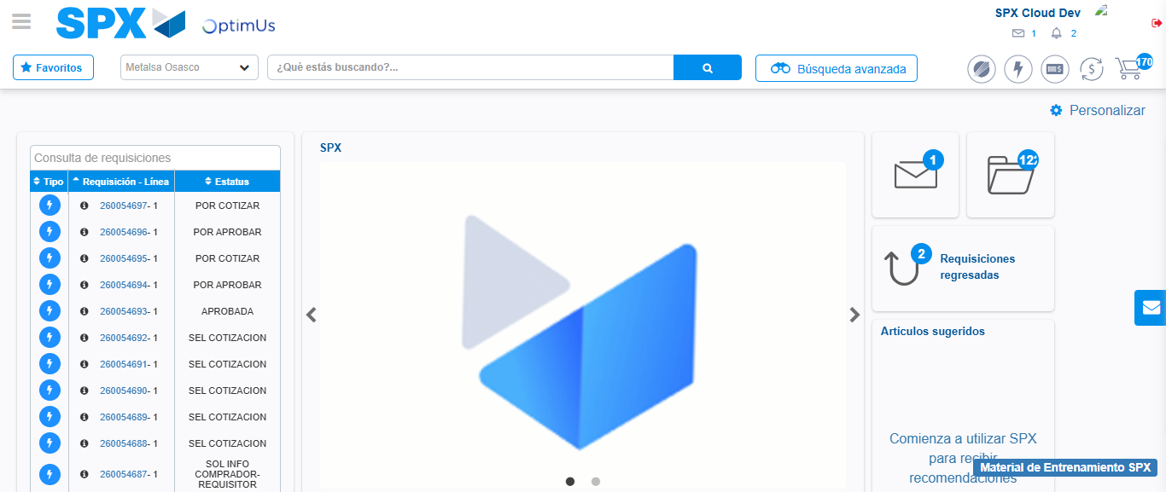Image file-name: QC_Testing-tc002_SPX_Dev5_Crear_Requisicion_Spot_Con_FAD_Tipo_Cobro_CC-1785975825556

Step 9 - Log Out : Log Out SPX
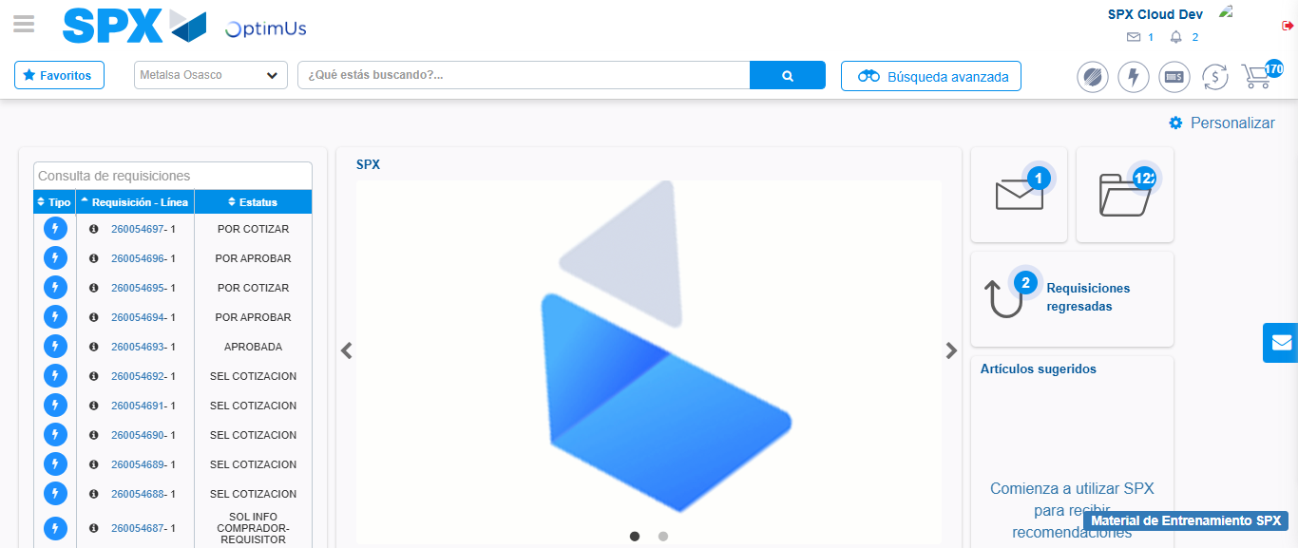Image file-name: QC_Testing-tc002_SPX_Dev5_Crear_Requisicion_Spot_Con_FAD_Tipo_Cobro_CC-1785975825906

